**CS-630-151 DATABASE**

**Part II - Oracle 12c**

Prof. Nilesh Shah

Pinal Patel (0170114)

**Introduction**

The store industry is a multi-billion-dollar industry. It touches everyone on society since we all regularly shop for all the items. Through tough competition a store must run efficient and reduce cost overruns. This includes using updated information in its purchasing decisions, inventory control, store stocking, customer information and a host of other business concerns. The business of stores is the ability to provide their customers with well-priced and fresh food items every day. This seemingly simple concept is very complex when put into practice. The company must source its inventory from different stores. They must buy at a competitive price then deliver the items to the individual store quickly. They must handle items as the seasons change. They must provide quick checkout service to their customers and be able to keep stores stocked with high velocity items. Stores also have many customers and management to make the business work is very difficult. Operationally these many moving parts plus many customers combine for a complex operation with tight profit margins. Inventory in the stores runs in real time and some store even have systems in place to automatically re-order items from their distribution warehousing. Many of these capabilities are only possible through the use of an advanced RDMS system.

**Data gathering, operations on data, and reports**

Customer information is critical to any successful business and the store business is no exception. Each customer will have basic information stored and this will be linked to their purchases. Managers can run reports viewing which store they shopped at, what they bought, how many total transactions and how much money they spent. Customers have to be able to select product for checkout. They also will need to have their purchases subtotaled so they know what they will have to pay. After the transaction is complete, a receipt should be displayed. For this project, there will be a web form a user, customer, can choose items and add them to their checkout basket. Once the items are selected and added they will be deducted from inventory. There will be no actual commerce mechanism in this mock up.

Management reports needed for management will have to answer questions including the current status of inventory quantity in store, price per item, customer activity, and sales totals. Inventory report(s) will include quantity in each store and the value of the current inventory. The report will have all details that will be used to reset all inventory items to a preset quantity and date so a user can simulate purchasing items multiple times. In the real world the store would order more inventory from their warehouse.

**Entities**

Customer

Order

Supplier

Stock

Order

Payment

Delivery

**Relationship between entities:-**

1. A customer can have one and only one Address , phone number and accordingly will be assigned a customer ID.
2. A customer can place zero, one or many orders.
3. The customer orders will be shown in order Table
4. The Inventory i.e stock table will be refilled and every stock will have a stock ID
5. The items will be procured from suppliers and the details will be stored in suppliers table.
6. The customer can pay through cash, credit card, debit card or can also use coupons.
7. The customer can choose for a pickup of items from store or can be delivered, these details will be stored in Delivery table

**Database Design:**

**Entity Relationship Diagram (E-R-D):**

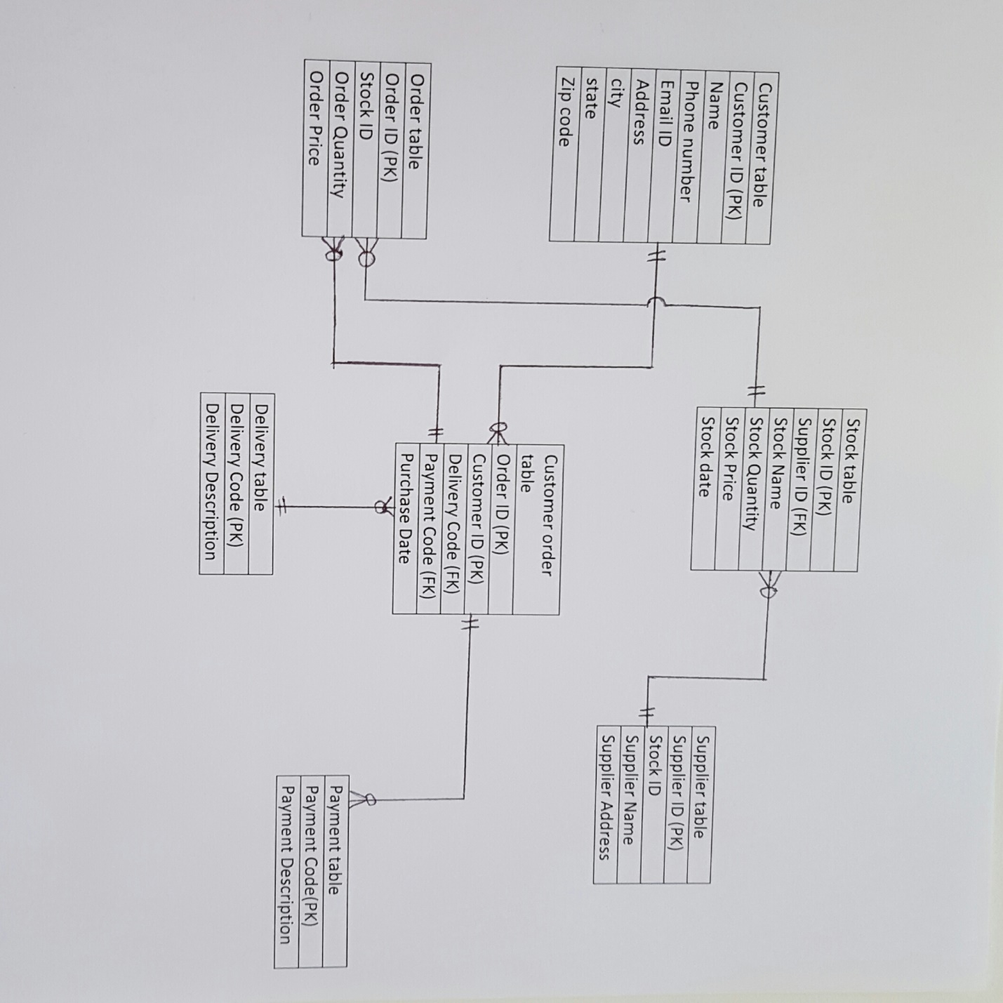

1. **Create tables using DDL queries. Add appropriate data to each table.**

* **CUSTOMER:**

CREATE TABLE CUSTOMER_B(CUSTOMERID NUMBER(5),

NAME VARCHAR2(90)NOT NULL,

PHONENUM VARCHAR2(15)NOT NULL,

EMAILID VARCHAR2(30),

ADDRESS VARCHAR2(30),

CITY VARCHAR2(20),

STATE VARCHAR2(2)NOT NULL,

ZIPCODE VARCHAR2(7)NOT NULL,

CONSTRAINT CUSTOMER_B_CUSTOMERID_pk PRIMARY KEY (CUSTOMERID));

ALTER TABLE CUSTOMER_B

ADD CONSTRAINT CUSTOMER_B_STATE_uk UNIQUE (STATE);

**INSERT:**

INSERT INTO CUSTOMER_B(CUSTOMERID,NAME,PHONENUM,EMAILID,ADDRESS,CITY,STATE,ZIPCODE)

VALUES ('101','PILARACKERMAN','4015-555-0194','PILAR.ACKER@GMAIL.COM','8808BACKBAYST.','JERSEYCITY','NJ',07306);

INSERT INTO CUSTOMER_B(CUSTOMERID,NAME,PHONENUM,EMAILID,ADDRESS,CITY,STATE,ZIPCODE)

VALUES ('102','MARTINBANKOV','402-565-0294','MARTIN.BK@GMAIL.COM','78RIVERSIDEDR.','WOODBRIDGE','NY',08817);

INSERT INTO CUSTOMER_B(CUSTOMERID,NAME,PHONENUM,EMAILID,ADDRESS,CITY,STATE,ZIPCODE)

VALUES ('103','CAMDADAVID','456-213-1432','CAMD.DAV@GMAIL.COM','55NEWTON','SEATTLE','WA',88102);

INSERT INTO CUSTOMER_B(CUSTOMERID,NAME,PHONENUM,EMAILID,ADDRESS,CITY,STATE,ZIPCODE)

VALUES ('104','DANMIMIKE','465-785-5845','DAM.MIK@GMAIL.COM','22MARKETST.','WOODINVILLE','CA',88072);

INSERT INTO CUSTOMER_B(CUSTOMERID,NAME,PHONENUM,EMAILID,ADDRESS,CITY,STATE,ZIPCODE)

VALUES ('105','INEZDENIS','585-585-6894','INEZ.DENIS@GMAIL.COM','2158GREEKST.','TACOMA','NC',56892);

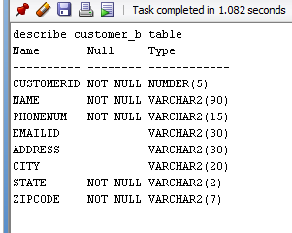

select * from customer_b

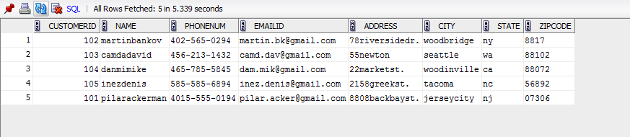

* **ORDER:**

CREATE TABLE ORDER_B(ORDERID NUMBER(5),

STOCKID NUMBER(5),

ORDERQUANTITY VARCHAR2(10) DEFAULT(1),

ORDERPRICE NUMBER (7,2) NOT NULL,

CONSTRAINT ORDER_B_ORDERID_pk PRIMARY KEY (ORDERID));

**INSERT:**

INSERT INTO PPATEL0114.ORDER_B(ORDERID,STOCKID,ORDERQUANTITY, ORDERPRICE)

VALUES(201, 303, '10',557.50);

INSERT INTO PPATEL0114.ORDER_B(ORDERID,STOCKID,ORDERQUANTITY, ORDERPRICE)

VALUES(202, 304, '20',80.40);

INSERT INTO PPATEL0114.ORDER_B(ORDERID,STOCKID,ORDERQUANTITY, ORDERPRICE)

VALUES(203, 302, '30',171.90);

INSERT INTO PPATEL0114.ORDER_B(ORDERID,STOCKID,ORDERQUANTITY, ORDERPRICE)

VALUES(204, 301, '20',817.00);

INSERT INTO PPATEL0114.ORDER_B(ORDERID,STOCKID,ORDERQUANTITY, ORDERPRICE)

VALUES(205, 305, '40',1421.20);

INSERT INTO PPATEL0114.ORDER_B(ORDERID,STOCKID,ORDERQUANTITY, ORDERPRICE)

VALUES(201, 303, '10',557.50);

INSERT INTO PPATEL0114.ORDER_B(ORDERID,STOCKID,ORDERQUANTITY, ORDERPRICE)

VALUES(202, 304, '20',80.40);

INSERT INTO PPATEL0114.ORDER_B(ORDERID,STOCKID,ORDERQUANTITY, ORDERPRICE)

VALUES(203, 302, '30',171.90);

INSERT INTO PPATEL0114.ORDER_B(ORDERID,STOCKID,ORDERQUANTITY, ORDERPRICE)

VALUES(204, 301, '20',817.00);

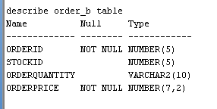

select * from order_b

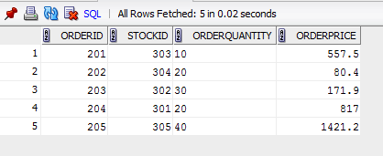

* **ORDER DETAIL(CUSTOMER ORDER)**

CREATE TABLE ORDDET_B(ORDERID NUMBER(5),

CUSTOMERID NUMBER(5),

DELIVERYID NUMBER(1)NOT NULL,

PAYMENTID NUMBER(1)NOT NULL,

PURCHASEDATE DATE NOT NULL,

CONSTRAINT ORDDET_B_ORDERIDCUSTOMERID_pk PRIMARY KEY (ORDERID,CUSTOMERID));

ALTER TABLE ORDDET_B

ADD CONSTRAINT ORDDET_B_DELIVERYID_fk FOREIGN KEY (DELIVERYID) REFERENCES DELIVERY_B (DELIVERYID);

ALTER TABLE ORDDET_B

ADD CONSTRAINT ORDDET_B_PAYMENTID_fk FOREIGN KEY (PAYMENTID) REFERENCES PAYMENT_B (PAYMENTID);

ALTER TABLE ORDDET_B

ADD CONSTRAINT ORDDET_B_CUSTOMERID_fk FOREIGN KEY (CUSTOMERID) REFERENCES CUSTOMER_B (CUSTOMERID);

ALTER TABLE ORDDET_B

ADD CONSTRAINT ORDDET_B_ORDERID_fk FOREIGN KEY (ORDERID) REFERENCES ORDER_B (ORDERID);

**INSERT:**

INSERT INTO ORDDET_B(ORDERID,CUSTOMERID,DELIVERYID,PAYMENTID,PURCHASEDATE)

VALUES (201,104,1,3,'22-DEC-2016');

INSERT INTO ORDDET_B(ORDERID,CUSTOMERID,DELIVERYID,PAYMENTID,PURCHASEDATE)

VALUES (204,105,2,1,'16-DEC-2016');

INSERT INTO ORDDET_B(ORDERID,CUSTOMERID,DELIVERYID,PAYMENTID,PURCHASEDATE)

VALUES (205,101,2,2,'20-NOV-2016');

INSERT INTO ORDDET_B(ORDERID,CUSTOMERID,DELIVERYID,PAYMENTID,PURCHASEDATE)

VALUES (202,103,1,4,'1-JAN-2016');

INSERT INTO ORDDET_B(ORDERID,CUSTOMERID,DELIVERYID,PAYMENTID,PURCHASEDATE)

VALUES (203,102,2,4,'06-DEC-2016');

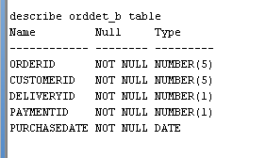

select * from orddet_b

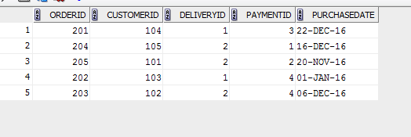

* **DELIVERY**

CREATE TABLE DELIVERY_B(DELIVERYID NUMBER(1),

DELIVERYDESC VARCHAR2(60)NOT NULL,

CONSTRAINT DELIVERY_B_DELIVERYID_pk PRIMARY KEY (DELIVERYID));

ALTER TABLE DELIVERY_B

ADD CONSTRAINT DELIVERY_B_DELIVERYDESC_CK CHECK (DELIVERYDESC= 'PICKUP' OR DELIVERYDESC ='HOME DELIVERY');

**INSERT:**

INSERT INTO delivery_b(deliveryid,deliverydesc)

VALUES (1,'Pickup');

INSERT INTO delivery_b(deliveryid,deliverydesc)

VALUES (2,'Home Delivery');

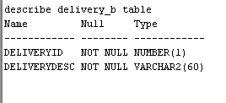

select * from delivery_b

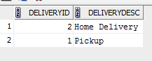

* **PAYMENT**

CREATE TABLE PAYMENT_B(PAYMENTID NUMBER(1),

PAYMENTDESC VARCHAR2(60)NOT NULL,

CONSTRAINT PAYMENT_B_PAYMENTID_pk PRIMARY KEY (PAYMENTID));

**INSERT:**

INSERT INTO PAYMENT_b(PAYMENTid,PAYMENTdesc)

VALUES (1,'CASH');

INSERT INTO PAYMENT_b(PAYMENTid,PAYMENTdesc)

VALUES (2,'Credit card');

INSERT INTO PAYMENT_b(PAYMENTid,PAYMENTdesc)

VALUES (3,'Debit card');

INSERT INTO PAYMENT_b(PAYMENTid,PAYMENTdesc)

VALUES (4,'coupon');

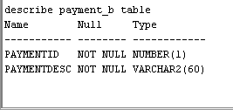

select * from payment_b

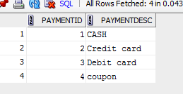

* **SUPPLIER**

CREATE TABLE SUPPLIER_B(SUPPLIERID NUMBER(5),

SUPPLIERNAME VARCHAR2(60)NOT NULL,

SUPPLIERPHONENUM VARCHAR(15)NOT NULL,

SUPPLIERADDRESS VARCHAR2(60),

CITY VARCHAR2(10),

STATE VARCHAR2(7),

ZIPCODE VARCHAR2(10),

CONSTRAINT SUPPLIER_B_SUPPLIERID_pk PRIMARY KEY (SUPPLIERID));

**INSERT:**

INSERT INTO PPATEL0114.SUPPLIER_B

(SUPPLIERID ,SUPPLIERNAME,SUPPLIERPHONENUM,SUPPLIERADDRESS,CITY,STATE,ZIPCODE)

VALUES

(401,'PINAL INC','201-123-6789','342BACKBAY','CONGAREE','CA','90097');

INSERT INTO PPATEL0114.SUPPLIER_B

(SUPPLIERID ,SUPPLIERNAME,SUPPLIERPHONENUM,SUPPLIERADDRESS,CITY,STATE,ZIPCODE)

VALUES

(402,'JAISON INC','201-123-6799','1010 EDGEWATER','EDGEWATER','NJ','90098');

INSERT INTO PPATEL0114.SUPPLIER_B

(SUPPLIERID ,SUPPLIERNAME,SUPPLIERPHONENUM,SUPPLIERADDRESS,CITY,STATE,ZIPCODE)

VALUES

(403,'JD INC','201-123-6689','28LAKETONST','FULTON','CA','90085');

INSERT INTO PPATEL0114.SUPPLIER_B

(SUPPLIERID ,SUPPLIERNAME,SUPPLIERPHONENUM,SUPPLIERADDRESS,CITY,STATE,ZIPCODE)

VALUES

(404,'SYED INC','201-123-6989','452COLUMBUSDR','GROVE','CA','90092');

INSERT INTO PPATEL0114.SUPPLIER_B

(SUPPLIERID ,SUPPLIERNAME,SUPPLIERPHONENUM,SUPPLIERADDRESS,CITY,STATE,ZIPCODE)

VALUES

(405,'SHAH INC','201-551-6789','124MAINST','NORTHFIELD','CA','90098');

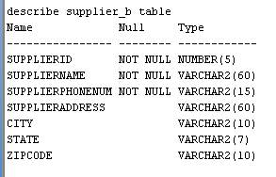

select * from supplier_b

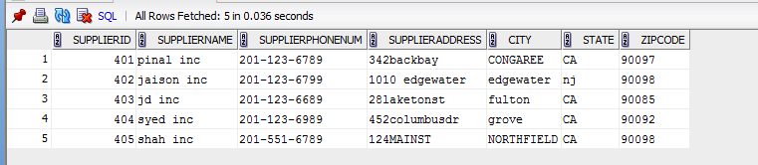

* **STOCK**

CREATE TABLE STOCK_B(STOCKID NUMBER(5),

SUPPLIERID NUMBER(5),

STOCKNAME VARCHAR2(60)NOT NULL,

STOCKQUANTITY NUMBER(10) DEFAULT(1),

COST NUMBER(7,2)NOT NULL,

STOCKDATE DATE NOT NULL,

CONSTRAINT STOCK_B_STOCKID_pk PRIMARY KEY (STOCKID));

ALTER TABLE STOCK_B

ADD CONSTRAINT STOCK_B_SUPPLIERID_fk FOREIGN KEY (SUPPLIERID) REFERENCES SUPPLIER_B (SUPPLIERID);

**INSERT:**

INSERT INTO PPATEL0114.STOCK_B(STOCKID,SUPPLIERID,STOCKNAME, STOCKQUANTITY, COST, STOCKDATE)

VALUES(301, 403, 'APPLE','120', 4.55, '12-DEC-2016');

INSERT INTO PPATEL0114.STOCK_B(STOCKID,SUPPLIERID,STOCKNAME, STOCKQUANTITY, COST, STOCKDATE)

VALUES(302, 401, 'ORANGE','130', 5.73, '11-NOV-2016');

INSERT INTO PPATEL0114.STOCK_B(STOCKID,SUPPLIERID,STOCKNAME, STOCKQUANTITY, COST, STOCKDATE)

VALUES(303, 402, 'VITAMINS','155', 55.75, '05-OCT-2016');

INSERT INTO PPATEL0114.STOCK_B(STOCKID,SUPPLIERID,STOCKNAME, STOCKQUANTITY, COST, STOCKDATE)

VALUES(304, 404, 'ICE CREAM','101', 20.50, '01-NOV-2016');

INSERT INTO PPATEL0114.STOCK_B(STOCKID,SUPPLIERID,STOCKNAME, STOCKQUANTITY, COST, STOCKDATE)

VALUES(305, 405, 'CAKE','211', 35.53, '16-NOV-2016');

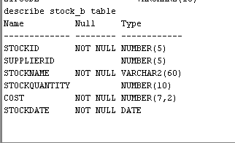

select * from stock_b

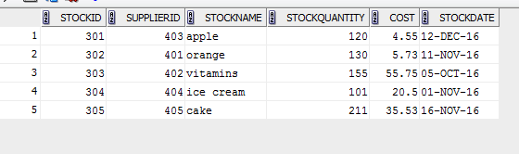

1. **CREATE SIMPLE/COMPLEX VIEWS FOR THE END-USERS.**

* **COMPLEX VIEW :**

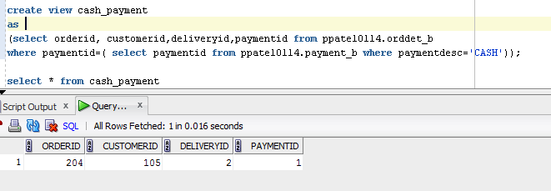

1. **DESIGN DATA RETRIEVAL QUERIES USING VARIOUS JOINS, FUNCTIONS, SET OPERATORS AND NESTED QUERIES.**

* **JOIN**

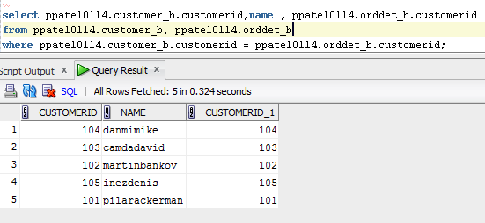

* **MULTIPLE JOINS;**

SELECT PPATEL0114.CUSTOMER_B.NAME CUSTOMER , PPATEL0114.ORDDET_B.PURCHASEDATE PURCHASEDATE, PPATEL0114.ORDER_B.ORDERPRICE PRICE, PPATEL0114.DELIVERY_B.DELIVERYDESC DELIVERY, PPATEL0114.PAYMENT_B.PAYMENTDESC PAYMENT

FROM PPATEL0114.CUSTOMER_B, PPATEL0114.ORDDET_B, PPATEL0114.ORDER_B, PPATEL0114.DELIVERY_B, PPATEL0114.PAYMENT_B

WHERE PPATEL0114.CUSTOMER_B.CUSTOMERID = PPATEL0114.ORDDET_B.CUSTOMERID

AND PPATEL0114.ORDER_B.ORDERID = PPATEL0114.ORDDET_B.ORDERID

AND PPATEL0114.DELIVERY_B.DELIVERYID = PPATEL0114.ORDDET_B.DELIVERYID

AND PPATEL0114.PAYMENT_B.PAYMENTID = PPATEL0114.ORDDET_B.PAYMENTID;

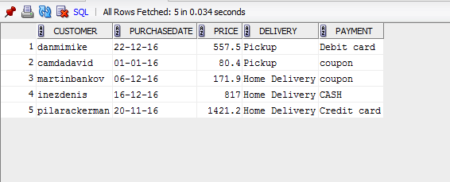

* **FUNCTIONS:**
* **AVG**

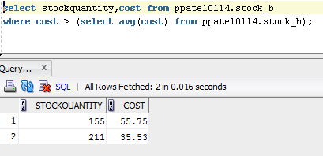

* **SUM**

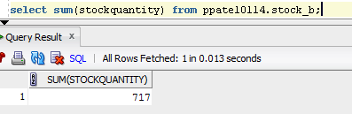

* **GROUP BY**

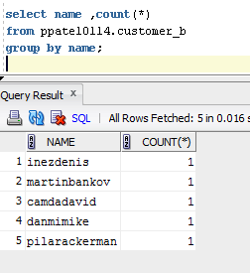

* **SET OPERATORS**

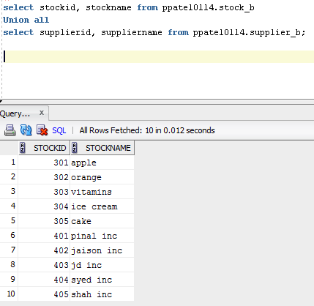

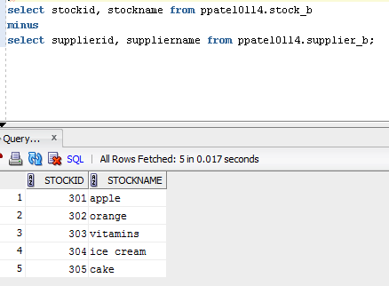

* **NESTED QUERY**

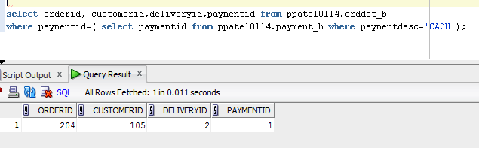

1. **UTILIZE VARIOUS DATABASE OBJECTS LIKE SYNONYM, VIEW, SEQUENCE AND INDEX.**

* **SYNONYM**

create synonym delivery

for delivery_b;

NOTE: We don’t have privileges on Synonyms.

* VIEW

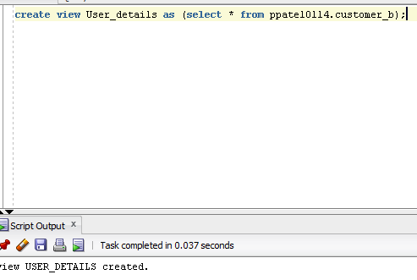

* **SEQUENCE:**

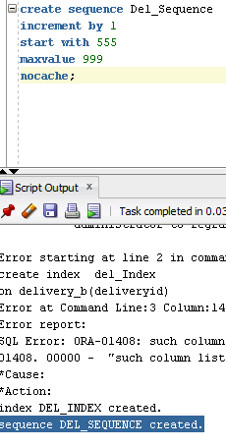

* **INDEX**

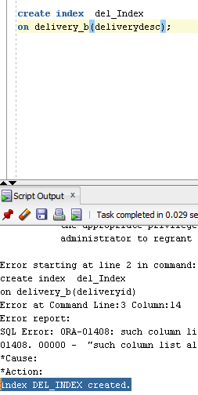

1. **IMPLEMENT USER ACCESS CONTROL FOR DIFFERENT OBJECTS.**

* **GRANT TO JAISON**

GRANT ALL

ON CUSTOMER_B

TO JVARGHESE9689;

GRANT ALL

ON SUPPLIER_B

TO JVARGHESE9689;

GRANT ALL

ON STOCK_B

TO JVARGHESE9689;

GRANT ALL

ON ORDER_B

TO JVARGHESE9689;

GRANT ALL

ON ORDDET_B

TO JVARGHESE9689;

GRANT ALL

ON DELIVERY_B

TO JVARGHESE9689;

GRANT ALL

ON PAYMENT_B

TO JVARGHESE9689;

* **GRANT TO JAYDEEP**

GRANT ALL

ON CUSTOMER_B

TO PJAYDEEPKUMAR5683;

GRANT ALL

ON SUPPLIER_B

TO PJAYDEEPKUMAR5683;

GRANT ALL

ON STOCK_B

TO PJAYDEEPKUMAR5683;

GRANT ALL

ON ORDER_B

TO PJAYDEEPKUMAR5683;

GRANT ALL

ON ORDDET_B

TO PJAYDEEPKUMAR5683;

GRANT ALL

ON DELIVERY_B

TO PJAYDEEPKUMAR5683;

GRANT ALL

ON PAYMENT_B

TO PJAYDEEPKUMAR5683;

* **GRANT TO AHMED**

GRANT ALL

ON CUSTOMER_B

TO SAHMED9665;

GRANT ALL

ON SUPPLIER_B

TO SAHMED9665;

GRANT ALL

ON STOCK_B

TO SAHMED9665;

GRANT ALL

ON ORDER_B

TO SAHMED9665;

GRANT ALL

ON ORDDET_B

TO SAHMED9665;

GRANT ALL

ON DELIVERY_B

TO SAHMED9665;

GRANT ALL

ON PAYMENT_B

TO SAHMED9665;

1. **USE PL/SQL BLOCKS (PROCEDURE/FUNCTION/PACKAGE/TRIGGER) FOR DATA MANIPULATION.**

* **FUNCTION**

CREATE FUNCTION BUYERS (J_ID IN NUMBER)

RETURN VARCHAR2

IS PRIMARY_DETAILS VARCHAR2(100);

BEGIN

SELECT NAME|| ' '|| PHONENUM INTO DETAILS FROM PPATEL0114.CUSTOMER_B WHERE CUSTOMERID=J_ID;

RETURN DETAILS;

END BUYERS;

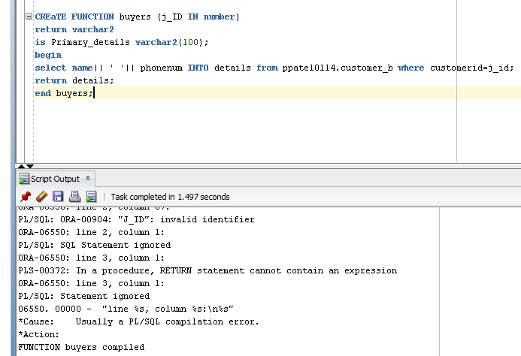

* **PROCEDURE**

CREATE

PROCEDURE SEARCH CUSTOMERID

(I_CUSTOMERID IN NUMBER,

O__NAME OUT VARCHAR2,

O_ADDRESS OUT VARCHAR2)

IS

BEGIN

SELECT NAME, ADDRESS

INTO O_NAME, O_ADDRESS

FROM PPATEL0114.CUSTOMER_B

WHERE CUSTOMERID = I_CUSTOMERID;

EXCEPTION

WHEN OTHERS THEN

DBMS_OUTPUT.PUT_LINE('CUSTOMERID=' || TO_CHAR(I_CUSTOMERID) || 'DOES NOT EXIST.');

END;

